Name: Timothy Ng Tik Ti

ID: P7362270

Name and purpose of the chatbot

The bot is called TikyInsuranceDefinition bot. As a financial consultant there are many people who asks “what are the differences between this insurance and that?”. To make things smoother, even before the meet up with the client, this bot serves as an mini educational bot that provides definition to the top 5 type of insurances that people look out for. Additionally, it prompts clients to see if they want to purchase an insurance of the type that they searched up for, and allow them to input their personal information to be contacted by the advisor for an appointment, and for the advisor to do preliminary research on the products suitable for the client prior to the meet up.

Intents/follow-up/default welcome intents and fulfilment used

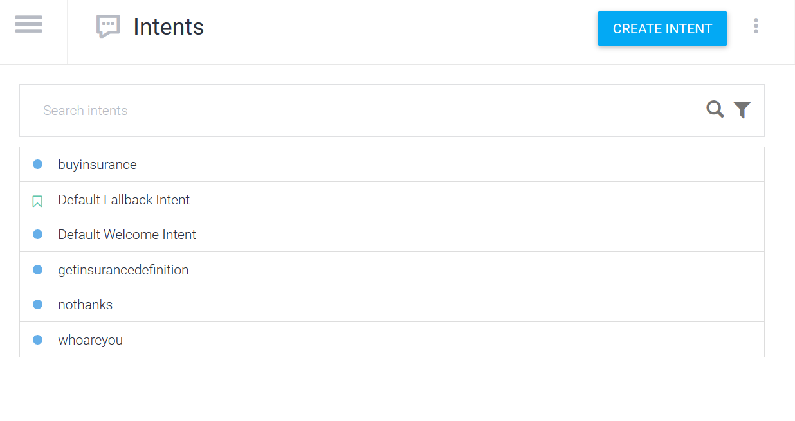

Fig 1. Intents used

The above shows the intent that’s being utilized. At the start user will be greeted by the welcome intent, and when asked ‘who are you’ the *whoareyou* intent will give a short introduction and asks what the client want to look up for.

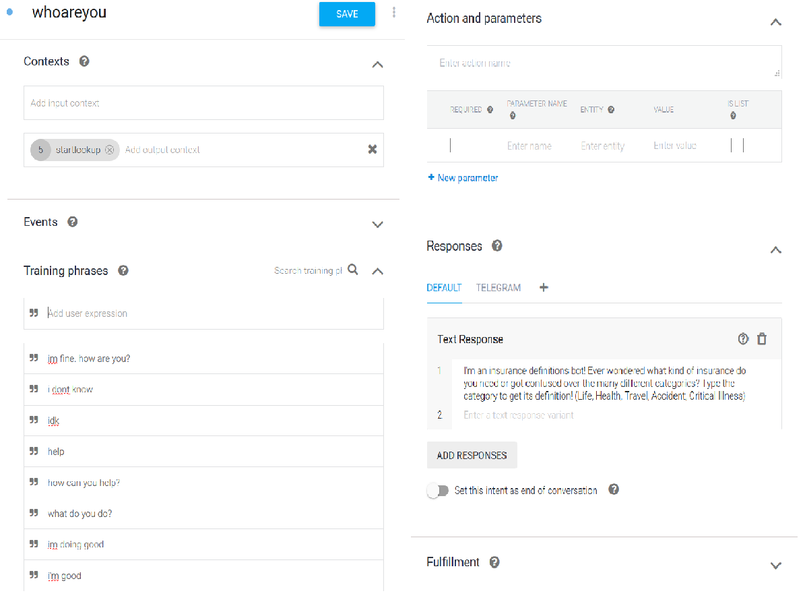  
Fig 2. whoareyou intent

Next getinsurancedefinition will get into firebase and retrieve the definition of prompted type of insurance, and proceeds to ask if client wants to purchase it as there is a discount currently.

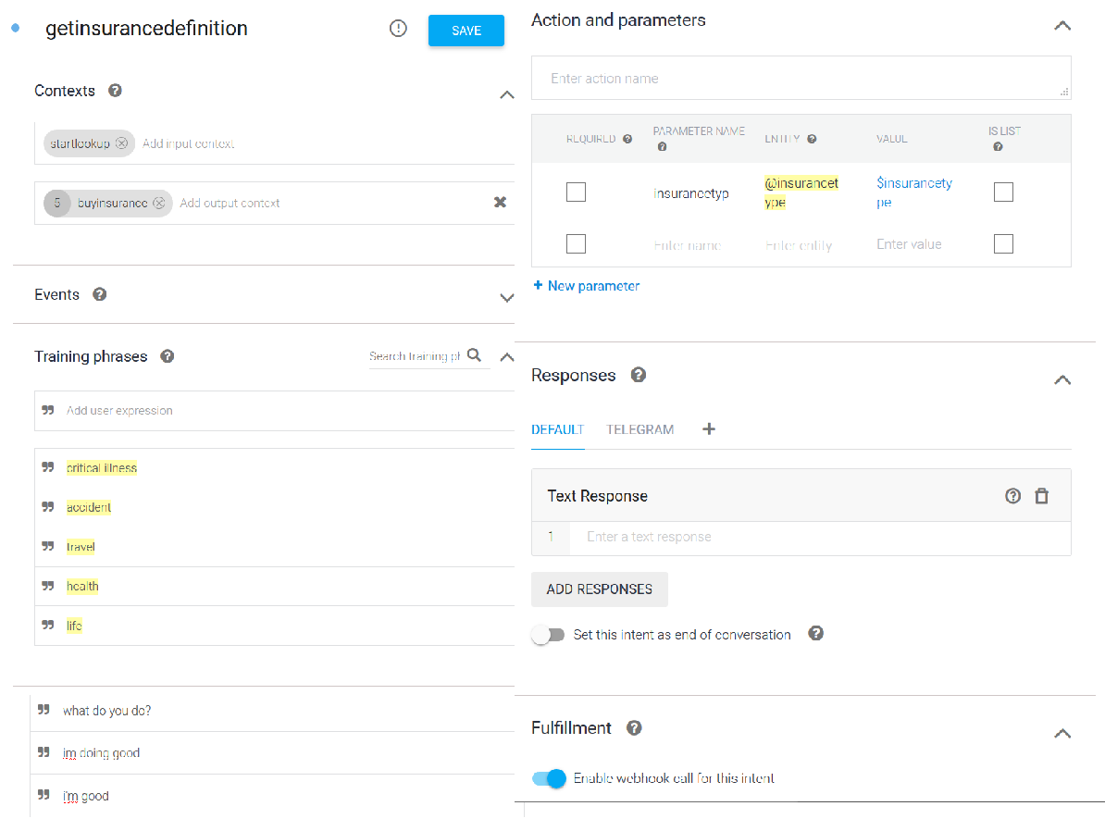

Fig 3. getinsurancedefinition intent

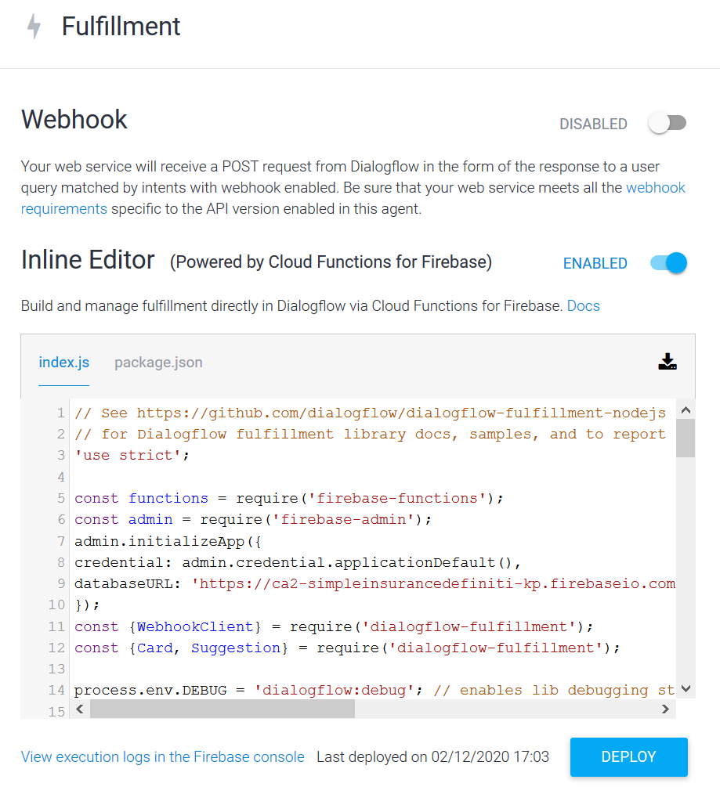

Fig 4. Inline Editor for Firebase fulfilment

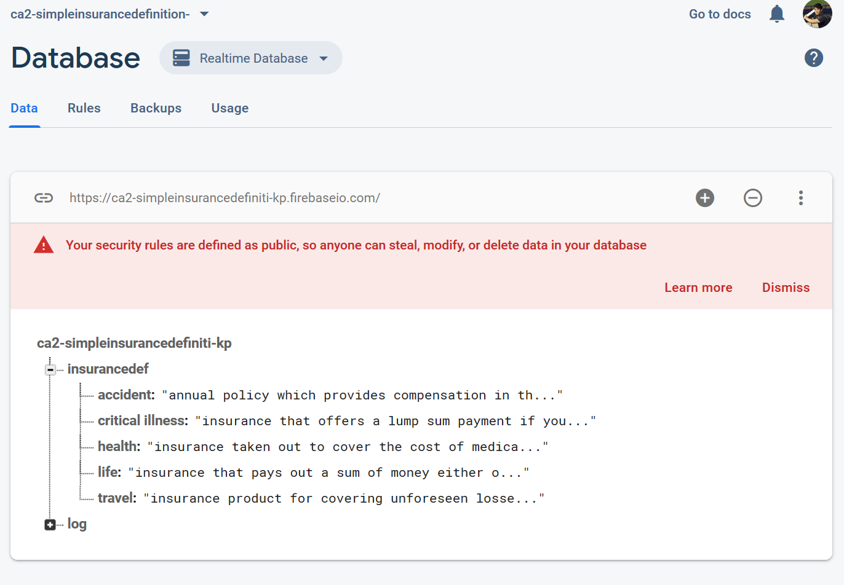

Fig 5. Firebase database for insurance definitions

Subsequently, if they say yes to purchase, *buyinsurance* intent will prompt user for their personal details. Or if they say no, the bot will end there as well.

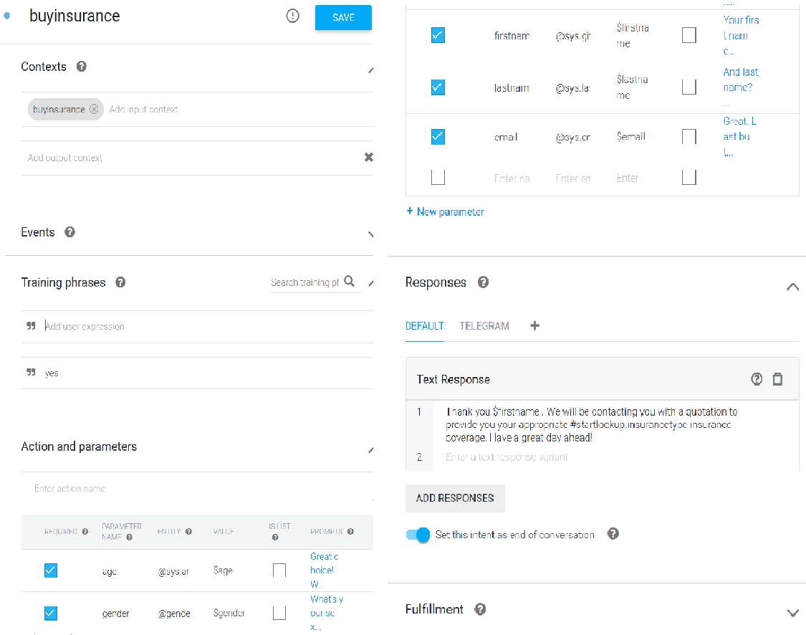

Fig 6. buyinsurance intent

An example of the conversation flow is below, with demonstration for the rich message and integration with Telegram:

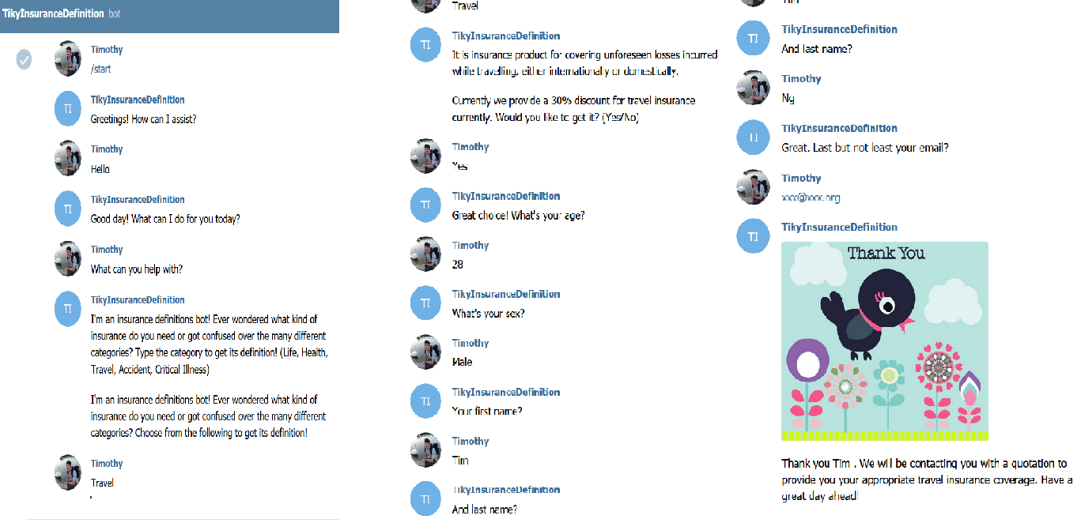

Fig 7. Conversation flow with telegram integration

Should the response be negative (ie. No thank you, no thanks, no etc) at any time, the *nothanks* intent will be activated and ends the conversation. Apart from the configured intents, the default intents are left untouched and default.

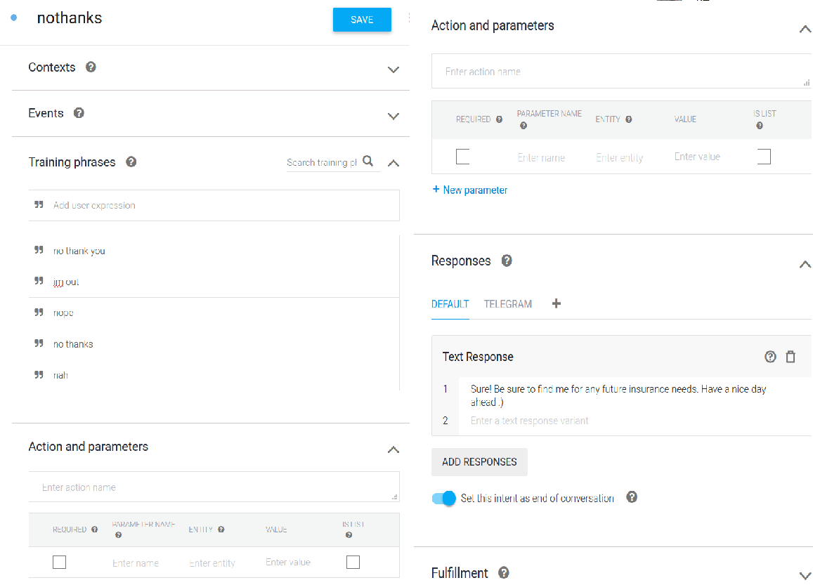

Fig 8. nothanks intent

Entities and parameters

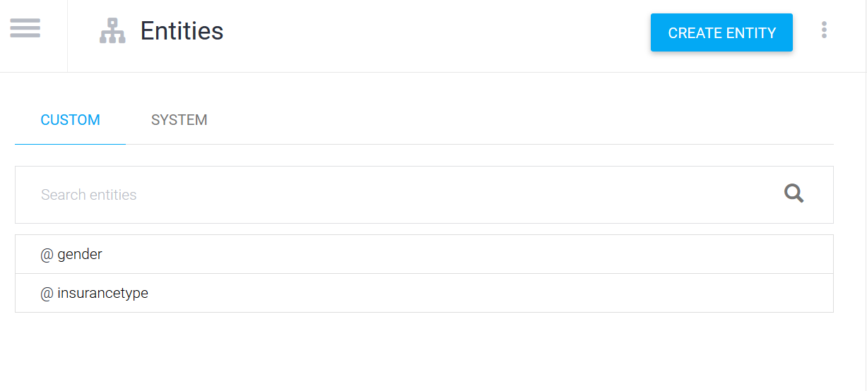

Fig 9. Entities used

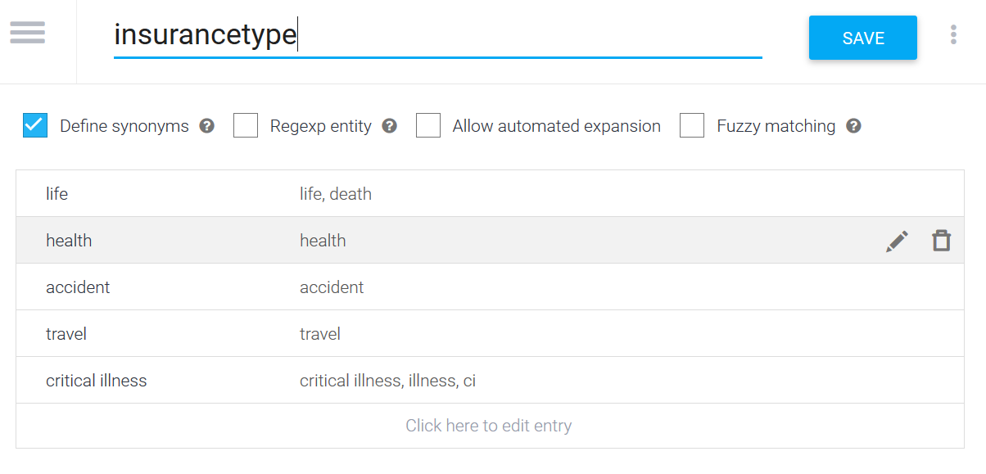

Fig 10. insurancetype entity used for Firebase database referencing

These were the entities. They are used to classify the different types of insurances. They are used as parameters to trigger database for its value for reference. The gender entity was used for client to key in personal information.

How input and output contexts were utilized

The input and output contexts were utilized to identify which type of insurance the client is looking out for, as well as to link the flow of the conversation. Refer to screenshots of intents above to see how the contexts are linked.

Training data sample

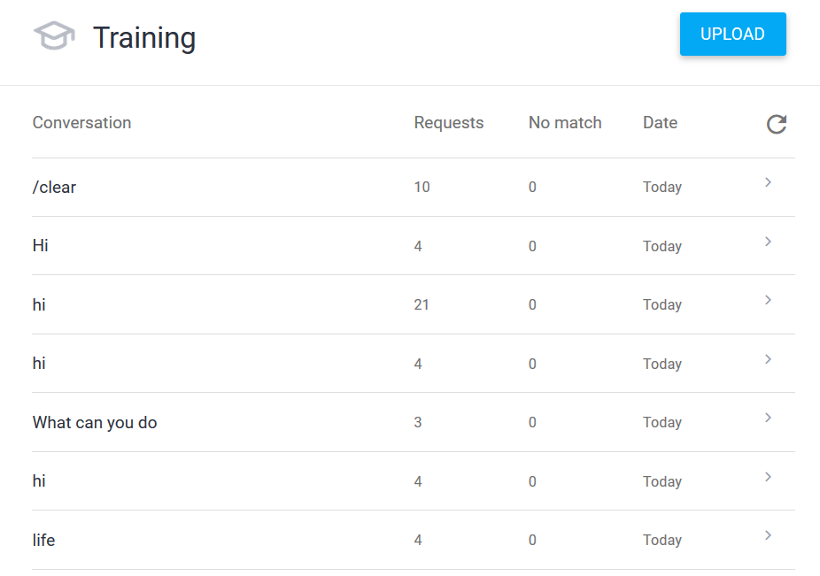

Fig 11. Training data

URL of the working chatbot

For web demo,

<https://bot.dialogflow.com/674f5111-cf3e-4be1-94a3-70b6e629496c>

For telegram integration,

@tikyinsuredef_bot